Ben Zimmerman
Fresh Start Christian Sober Living
Freelance Web Design/Tech Specialist
Stephen J. Kelly
Shane Lambert
Shanelambert122@msn.com
MKT 393
11/14/25

I – Background: Introduction to Company/Organization
Fresh Start Christian Sober Living is a family owned and operated group of sober living and rehab homes based out of Frisco, Texas. The company is Christ-Centered with faith being the first step in their recovery program. The goal of this company is identifying habits and working through them to help the patients better recover. The goal of rehabilitation has many steps walked through to fulfill eventual recovery and many of the people who have been through the program even end up becoming house managers, building a better sense of community within the company and support for those who need it the most. They do this through having weekly meetings with house residents to build strong community with all those living in the homes. Additionally, classes and supplemental learning are available for those who wish to strengthen their skills to be better prepared when returning to living a normal life once their time at the sober living homes has ended.
The industry that Fresh Start Christian Sober Living is in would be considered as within the healthcare industry. The company is small, private, and family owned, not traded on any markets and funding is raised by angel investors and found through the owner’s network. The company also relies heavily on donations for their daily operations, which recently been revamped as the previous donation site was no longer cost effective for the company. These donations are critical in providing many of the amenities for the homes, while investors providing larger sums may be used to purchase more homes, expanding the capacity for many people the homes are able to take in.
II- Environments
Competition: Nationally, the total market share of both inpatient and outpatient rehabilitation centers was valued at $16.8 billion in 2023, with a market growth forecast of 7.4% CAGR from 2024-2033, increasing to a total forecasted market value of $31.3 billion by 2033 (See figure 1). Rehabilitation program centers have the largest current market share, at 32%, while residential centers, such as Fresh Start Christian Sober Living, have significant forecasted growth within the next 10 years (1. Deb). North America has 47% of the rehabilitation center market share, with major companies such as Pfizer and Johnson & Johnson being the largest players globally (1. Deb). However, with Fresh Start being a regional player in the rehabilitation center business, a more accurate look at who their direct competitors would be is to look at specifically Texas rehab and sober living facilities. According to Newsweek, the top-rated Texas rehab and sober living facilities within the same regionality of Fresh Start Christian Sober Living are Turtle Creek Recovery Center and Nexus Recovery Center (Cooper 2). Turtle Creek Recovery Center is listed on many separate rehabilitation list websites, however there is no active website that could be opened to find any additional information about Turtle Creek. Turtle Creek is now under the Cenikor Foundation, as the link in the Newsweek article leads directly there. According to the Cenikor 2025 annual report, they have 13 locations across Texas and 1 location in New Mexico, making 14 locations total, in comparison to the 4 locations mainly in the Dallas area that Fresh Start Christian Sober Living maintains (Cenikor 3). Cenikor’s facilities are spread out in areas that Fresh Start may expand into in the future, making it a large competitor and obstacle to expansion for Fresh Start (see figure 14). However, the marketing department of Cenikor has made some mistakes, with Turtle Creek being touted as one of the best rehabilitation facilities, while having no website of its own or having no changes being made for Cenikor to appear more prominently among other Texas rehabilitation facilities. About Nexus Recovery Center, Nexus is a woman-only rehab and treatment center, which narrows down its potential to gain new clientele, however this is a potential loss in revenue for Fresh Start Christian Sober Living, because the company currently does not have any sober living facilities for women. However, there are plans within the company to begin work on a women’s house for recovery, as they have explored this vulnerability. The owner of Fresh Start has reached a similar conclusion as has been stated here. Nexus received over $18 million dollars in revenue, mostly from government funding, and is currently in the process of a full remodel of their campus which will cost them around $86 million dollars due to rising amounts of pregnant and young women seeking services, along with mothers, these new costs are in order to build new dormitories for these specific demographics. This is according to Nexus’s 2023 financial reports (see figures 2 and 3).
Technology: In general, the technology used within the industry of rehabilitation and health is constantly shifting. In addition to common sense technologies such as website builders such as WordPress and social media sites giving outreach to those that need it most, such as Facebook, Instagram, TikTok, and X, there are practical technologies such as breathalyzers and drug tests to check sobriety states. However, with advancements in practical technologies have allowed some rehab facilities to use more experimental therapies for patients. Some examples of this are new virtual reality (VR) therapies which allows patients to experience their triggers while maintaining their own safety within the facility (Samba Recovery 5). For patients in more remote conditions, or for those who do not have the means to live at a 24-hour facility, telehealth services are often invaluable, in addition to remote monitoring of blood alcohol limits and fluid drug tests (Sweeny 6). AI can also be used to custom tailor treatment plans and predict relapse triggers, although this technology still has a great many errors and kinks to work through to be used effectively. Currently, there are no large-scale data operations for marketing, but with the advent of new social media pages and work done on the website, data can begin to be collected on SEO, target market reach, and social media impressions. The work that has been done during this freelance job has had the benefit of learning and working closely using WordPress, a great experience as WordPress makes up over 60% of the CMS market share, beating out other website creation tools such as Shopify, Wix, and Squarespace (see figure 4). In addition, future work that is planned with Fresh Start Christian Sober Living will consist of using social media platforms to first set up and then market Fresh Start’s services through channels such as Instagram, Facebook, and X. AI will also play a large role in this, as there are many AI tools to generate social media release schedules in tandem with dates and times people are most likely to be on their phones, such as Musely AI, and using other tools such as Visual Studio Code to sift through the internet to find the most effective times to release posts.
Economy: Drug use and rehabilitation cost the US nearly $820 billion a year, between crime, healthcare, and lost work (NCDAS 7). Nearly $11 billion of this is exclusively healthcare costs, which is the specific realm in which Fresh Start Christian Sober Living operates in. The National Drug Control Budget specifically allocates $2.9 billion to supporting drug abuse prevention and recovery services (NCDAS 7). This is 6.5% of the total budget (See Figure 5). Drug abuse can be seen increasing with those who perceive economic distress, with subjective measures being a larger share of drug abuse increases at about 26%, while objective measures accounting for only 6% of the increase with those aged 50 or older who abuse drugs (Glei 8). What this means is that perceived subjective troubles on the horizon are linked to increasing drug abuse. Such things may include potential or realized recessions and depressions in the economy, or bearish markets, especially for those who are in the lower income class. This does not include alcohol, however, as alcoholism has been found to have a positive correlation in both lower socioeconomic status (SES) and higher socioeconomic status (See Figure 6, top graph as drug abuse with relative SES and bottom graph with alcoholism with relative SES). For context, the economy in 1995-6 was upward trending generally (Navellier 9), and it was also upward trending in 2011-2014, however to a far lesser extent and to lower heights than in 1995-6 (See Figure 7, both for 1995-6 and 2011-14).
Legal, Political, and Ethical Factors: A legal factor that impacts those companies that are involved in the rehabilitation industry is the understanding of Federal Discrimination Laws for hiring those who are in drug abuse treatment. Both the ADA (The Americans with Disabilities Act) and the Rehabilitation Act protect those who have disabilities by preventing discrimination from both public and private employers (National Library of Medicine (NIH) 10). The types of discrimination covered by these two laws protect disabled people from any discrimination against an opportunity to participate is the same goods, services, or privileges that any non-disabled person can do, however this can only happen if the disabled individual is qualified, which means they meet the essential requirements of the job without change to the job’s responsibilities (NIH 10). This means that even if one were to be disabled, they must still have the experience and skill to perform the job even with extra help given to them (NIH 10). The other exception is if one is a danger or threat to themselves or to others, with organizations required to make individual, case by case basis for each employee. If the person is no longer using drugs and has completed their rehabilitation program, that person should not be discriminated against, however if one has not yet completed their rehabilitation or is still using drugs, they are only fully protected about rehabilitation or health services (NIH 10). Regarding ethicality, there are several protections put into place to preserve those who are in recovery and those who have already recovered. All healthcare jobs must respect HIPAA and doctor patient privilege laws that are applicable, however companies that work in rehabilitation must work through additional ethical issues, one being the stigma that comes from bringing in those struggling with substance abuse disorders. Many rehabilitation and sober living facilities struggle with finding patients due to cost, lack of options in the area, or people with substance abuse disorders being too ashamed to seek help (Williamson 11). This puts pressure on both the company and the patients as the stigma of being judged for one’s decisions often puts current addicts into the position where they won’t seek help. The recovery relies on the patient’s willingness and independence to seek help, and oftentimes when potential patients seek help, their values, choices, and freedoms are not respected, making them less likely to reach out again for help (Williamson 11). What may fix this cycle is taking a more personal, goal centered approach instead of more clinical, institutional goals which often don’t meet what the patient wishes to achieve. This gives the patient more autonomy while still having oversight and help in making their decisions while in recovery (Williamson 11). Political factors that may be of interest to those in the rehabilitation industry are the recent change in presidency from Joe Biden to Donald Trump. Those rehabilitation centers seeking federal funding are seeing President Trump slash addiction funding where Biden previously expanded it greatly in 2023 with a bipartisan effort that saw drug overdose deaths increasingly decline in recent years (Mann 12). Now, Trump is delaying the dispersion of $140 million appropriated to fentanyl overdose response efforts, which may see another resurgence of deaths in the fight against drug deaths and recovery from drugs (Mann 12). If this continues, more funding to rehab and drug prevention programs may get cut due to the new government interest in cutting funds.
Customer Trends: The rehabilitation industry is trending more towards private ownership of non-profit and government funded facilities. The highest owned rehabilitation centers continue to be private, for-profit and private non-profit institutions while state, federal and local institutions are in far less number (see Figure 8). While for-profit ownership fell from 2022 to 2023 it rebounded to higher levels in 2024, while non-profit ownership continues to steadily climb (see Figure 8). Looking at governmental ownership, local government owns almost the same amount as both Federal and State-owned rehabilitation centers, with state governmental ownership rising slightly in 2024 (Fig 8). This could mean that states are taking a greater role in the administration of rehabilitation and sober living facilities, however the vast share of ownership still lies with private companies. These private companies have far lower rates having optionality of free treatment if the person cannot pay, while governmental rehabilitation has higher chance of granting free treatment if the individual is unable to pay (Fig 9). This shows that for-profit and even non-profit to a far lesser extent can retain a customer base with large amounts of privately owned institutions, while still retaining revenue streams with many different payment options without allowing individuals to not pay at all for services. The private institutions do this through offering more options for payment of services. While only 0.1% of all for-profit rehabilitation centers offer a no repayment option, they have higher rates of private healthcare acceptance than both non-profit and local, community owned rehabilitation facilities, with for-profit institutions also using federal military insurance at higher rates than both the non-profits and local community rehabilitation facilities (Fig 10). This highlights why so many companies are now moving towards a for-profit model, as more patients move into for-profit facilities due to the ease of access and varying payment options for care, which then additionally drive reinvestment into these centers and drives innovation with new technologies and techniques for better recovery for patients.
III- The Organization’s Marketing Mix
Target Market: Fresh Start Christian Sober Living is a B2C non-profit, therefore it will have 2 primary targets, it’s potential patients and its donors. Fresh Start Christian Sober Living currently has 4 houses, all for men, so therefore men in need of sober living separated from any potential triggers would be the primary market, since currently there is no home for women, although there are plans to open a new home for women, in order to expand the work being done by Fresh Start. Men are more likely to use drugs than women, at 19.1% of men while 14.6% of women use drugs (13). Fresh Start also tends to have an even split from urban and rural environments, being based in the suburbs of Dallas, however there is a higher likelihood of drug abuse being in an urban environment, if only by about 3% (13). Fresh Start is also a sober living facility that includes strong ties in the Christian Faith and although all are welcome, there is a focus on rehabilitation and recovery through the Christian lens, so those who identify themselves as Christian either in the past and have lapsed or consider themselves Christian currently are also a part of the primary market demographic. Fresh Start describes their program as “Christ-centered”, multiple times across the site, so undoubtedly it is one of their core values and one they wish to convey to their patients and individuals living in these homes. Income matters less when looking at who may be entering Fresh Start’s facilities, as different socio-economic statues are more precluded to use certain drugs, as higher income individual are using “club drugs” which include ecstasy, meth and LSD, while lower income individuals may resort to using and inhalants they find (13). Therefore, income does not play as large of a role as it would in many other healthcare subindustries. Regarding Fresh Start’s competition in the Dallas area, Nexus being a women’s only facility makes it about the complete opposite as Fresh Start, with no stake in the recovery of men at the current moment, and no indication in any of their supplemental or annual reports that they plan to expand into men’s recovery. Cenikor, the other competitor mentioned above, is a more corporatized and large-reaching company within the recovery industry, without much of the understanding thoroughly of local markets, as it is much more spread out over larger areas. Cenikor also has the disadvantage of not having as refined of a target market and a regional hold as Fresh Start. The target market for donations for Fresh Start also depends and relies heavily on the Christian virtue of generosity. The owner and co-owner of Fresh Start are heavily involved in the Christian community in the Dallas suburbs area, and they use connections forged through the church to gain private donors and investors who share those same virtues taught by The Bible. To summarize, Fresh Start’s two primary markets both share Christian overtones, with those seeking recovery only being men now, with an even split in both urban and rural environments being in the suburbs, with no true focus on socio-economic levels with these individuals when seeking to market. The investors and donations rely heavily on connections built through shared Christian values and connections made through Christian spheres of influence in Dallas.
Offering: Fresh Start Christian Sober Living offers a sober living environment free from triggers and a community that focuses on independence, accountability, and a communal space with like-minded individuals. Specifically, Fresh Start has 4 locations across the Dallas suburban area, with options to live in either a single bedroom or in a double with a roommate. Information on price is private between the individual and the company. Amenities provided for the houses includes the full NFL package, bedding, cleaning supplies, and cooking supplies. One house also has a pool for those living there to enjoy. The program offered by Fresh Start includes weekly meetings that are mandatory to attend, a nightly breathalyzer, done on camera, and weekly drug tests. Rent must be paid to remain in the house, so many individuals choose to get jobs to help offset this. Fresh Start has strong ties in the court system, along with good relations with treatment centers and probation. There are multiple bedrooms to each home, with a house manager who is usually a former resident that wishes to remain on past the program and is decided on by the company. Photos of each location are available on Fresh Start’s website (Fig 11), along with several testimonial videos from both current and former residents of the homes. Fresh Start offers classes to clients, so that they may be able to improve their skills and learn new ones. This helps their reentry to society once they leave the program.
Revenue/Prices: The revenue stream of Fresh Start is twofold, coming both from rent collected from residents living in the homes, and with donations from generous individuals. As stated earlier, Fresh Start is currently in the process of becoming a for-profit privately owned sober living home and recovery company. Currently, donations come through the company website, and through private donor which the owner builds relations with and who are found through the strong Christians networks in Dallas and the surrounding areas. The donation website is currently being revamped, and a new donation site is replacing the old site, as the old donation site that Fresh Start previously used had both monthly fees and a percentage of each donation was also taken by the previous site. The new donation site the owners have chosen to use is Zeffy, and the freelancer who was previously brought on the redo the website is now working on setting up and linking the Zeffy page to the previously redone website. The site has almost been completely redone, as this is most people’s introduction to what the company is, although there is no pricing information here. People seeking to live in the houses must contact the owners directly to inquire about housing costs. The costs for residents of the sober homes is usually simply rent paid based on what room choice they have, between the single and the double. Currently, this has meant that there is only a small profit being made for the owners, as the company itself was a way of giving back to others in need. However, with the shift to for-profit, there is undoubtedly a restructuring of how payments will be taken and where that money ends up being allocated.
Distribution: The customers of Fresh Start Christian Sober Living come from many places. As stated earlier, Fresh Start has many strong connections in the court systems, so any sentencing that requires time spent in a sober living facility is often sent to Fresh Start homes to serve in the rehabilitation efforts. This provides a steady stream of residents within Fresh Start, while their website provides much better information about what it is that Fresh Start does with its goals and mission statement there for potential residents to learn more. There is no application portal for residency within the homes, as people seeking to live in a home must speak with the owner or house manager to even be considered. These homes are in high demand, as there is a constant need for quality sober living facilities. The other way is through word of mouth, as many people have turned their lives around successfully through the program offered at Fresh Start, and this can be seen on the revamped Fresh Start website, with several testimonials to show how well the program works and the improvement many of these current and former residents have seen both during and after their stays in the homes. Between high demand from the legal system and word of mouth from people have successfully graduated from the program, Fresh Start has ample ways it distributes information about what it does to new potential residents.
Marketing Communication: Currently, Fresh Start Christian Sober Living has only a website in terms of marketing it does to bring in new potential residents, and this website was only recently revamped. Originally, the website had not been updated in several years and had a very aged look to it. It has been revamped to include multiple tabs of testimonials, pictures of all locations owned by the company, and mission statement and goals featured prominently on the site. The design overall now looks much more professional for the modern era, with sleeker color tones and button placement to allow ease of access, and hyperlinks to different pages where they are spoken on to allow easier exploration of the site. There is plans by the owner to also set up several social media channels to expand the marketing of Fresh Start, which the same employee that revamped the website would work on, as he is currently preparing a pitch deck with SMART goals for each channel’s growth and performance, potential email campaigns and goals, and which in will be expanded on later within this paper. Currently, however, Fresh Start currently has a barebones online presence which is begging to be expanded upon to truly expand the company along with the restructuring to a more for-profit business model. The company measures if its methods are effective by seeing at the current moment how many rooms are full at time, which there usually are few if any at all, as it has built a strong reputation through word of mouth and legal connections. Since it is a small, family owned, non-profit entity with only local coverage, Fresh Start has not needed much online marketing, however, to reach its new company goals, it will need to build new channels of delivery for its message to continuously grow. As for competitor channels, Nexus Recovery has both a Facebook, Instagram, and LinkedIn presence, so even with their more concentrated target market, they have more visibility online. In addition to annual reports being released by the company that provides transparent and detailed news as to what the company has planned next. This gives them great potential to reach new residents, volunteers, and donors, which gives them a far larger reach than Fresh Start at the current moment. Nexus’s Instagram has a total of 1558 followers, with an average of about 1% engagement on each post, which is a bit low with the follower count and Instagram being their primary social media account. However, the account page of Nexus is well made, with several highlights of important events and stories they share (See figure 12). Cenikor has all major social media platforms, with Facebook, Instagram, LinkedIn, TikTok, X, and YouTube. The TikTok, X, YouTube, and Facebook are not very active, with their X account not having any posts despite having the account since 2012 (see fig 13). This could mean that Cenikor does not prioritize digital channels when marketing to new residents, volunteers, or donors, instead relying on other channels. Cenikor may use similar legal connections or similar word of mouth as Fresh Start uses. The issue this presents is as Fresh Start readies itself to expand, it may encounter troubles if Cenikor already has strong connections in a region that Fresh Start wishes to expand into. Similarly to Nexus, Cenikor has easy to access buttons to donate, volunteer, and apply for help in gaining residency in their facilities.
IV- SWOT Analysis
Strength: Regionally, Fresh Start has an advantage over competitors with its relationships in local courts and legal systems, often having people sent to live in their sober homes as a part of recovery deals reached by courts. Another advantage Fresh Start has is the specialized niche it has created for itself. Being a Christo-centric recovery and sober living facility, and the owners continuously strengthening connections and relationships with members of the Christian community in the Dallas area. This gives Fresh Start ample amounts of donors and volunteers willing to help reach Fresh Start’s goals as these volunteers share the same values and goals as the company. Fresh Start being a Christian focused sober living facility also gives it more credibility in its mission to rehabilitate residents struggling with substance abuse disorder. With so many testimonials available on Fresh Starts website, it’s brand recognition at least locally with individuals and families will be a great strength for it moving forward, especially if they wish to expand further into other regions in Texas. Fresh Start’s community forming program builds a welcoming and strong culture for all individuals involved. Finally, the fact that most if not all slots in all houses ran by Fresh Start are filled is a great strength as it shows how in-demand the service they provide to the community is.
Weakness: Fresh Start has some large weaknesses if it wants to expand successfully, specifically in the digital space in both social media and email. Fresh Start has no social medias to speak of and although it is in process to begin work on that, social media channels often take time to establish and build a large and engaged audience. This weakness is especially difficult to overcome if Fresh Start is to expand beyond its previously established region, as its name will not have the same recognizability that it does in the Dallas area. No social media also hurts Fresh Start’s ability to generate revenue based on donations, and many potential volunteers as there is no current option for volunteering within the Fresh Start organization. The Fresh Start owners also need to address the need of some an application form that potential customers can fill out to receive more information through email about Fresh Start, while also serving as another potential; point of contact to the Fresh Start staff. Even if there is no availability in any of the homes, this builds rapport with the Fresh Start staff, making it more likely that these individuals may return when there is availability, potential to join an email list with buttons to donate and volunteer could also add to the Fresh Start pipeline, as without it the staff seems to be hard to contact. Additionally, the recent transition to a new donation site and the previous donation site’s lack of accessibility in its design may cause a bit of a shake up for donations, since when the donation site is down and being worked on, there will be no way for donors to donate, a critical source of income for Fresh Start. The time at which the website is down and being worked on is critical so there is a smaller amount of donations being missed out on by the company. Another weakness in Fresh Start’s current plan is the restructuring to become a for-profit organization from a non-profit one. This coming at a time when the company is also seeking to expand could be too much to do at once, however this is only speculation as there has been no indication that the company is incapable of doing both. The restructuring could split focus in many different directions between managing the already established houses, restructuring to a for-profit model, and seeking to purchase more sober living facilities and expanding into new regions in Texas.
Opportunities: External opportunities developing for Fresh Start include the advent of AI, which may help maximize social media and email campaign efficiency, building a relatively large following quicker than it would take without AI analyzation tools. A couple of examples of this are, as mentioned earlier in the Technology segment, Musely AI, which will analyze peak social media usage times and dates, and use that to craft the most efficient post calendar for each social media channel. This cuts out much of the busywork when it comes to researching at which times potential customers will be online and instead sets the focus more on creating quality content. Additionally, tools such as Visual Studio Code have built in AI features that allow it to take over monitors and be granted full access to the web without long prompts from the user or paying for external AI tools. This allows for the compilation of great amounts of data, which the AI can then sift through to better understand cutomer trends. AI can also be used to create a fast-acting help bot in the browser website for Fresh Start, giving advice to potential customers as to how to best help in event of emergency or to direct potential clients where to find what they need. Other opportunities, such as new large donors being introduced to the Fresh Start donor list gives a well-rounded external opportunity spread for the future. These new donors could provide the funding for Fresh Start to achieve multiple goals simultaneously. The industry is growing, with increases in the number of for-profit business model for rehabilitation centers (Fig 8). Fresh Start is positioned well as a regional organization with already established connections in the legal space and 4 homes that often have no openings. Expanding to fit this new demand will see Fresh Start capitalizing on the declining rates of both non-profit and government run rehabilitation centers.
Threats: Most external threats to Fresh Start’s expansions into new regions in Texas are the competitors discussed earlier. With Fresh Start considering opening a Women’s sober house, Nexus recovery centers would become a direct competitor, and with them already being an established name in the Dallas area when it comes to women’s recovery, it could prove difficult for Fresh Start to overcome. Nexus has had to build around the more difficult prospect of tailoring their care specifically for women, offering for children to live with their parents and pregnant women being accepted at the facilities, Fresh Start will have to adapt its program to better fit the difficult prospect, potentially having to hire on more employees who understand women’s recovery and who can tailor Fresh Start’s program to fit that (4). Cenikor is undoubtedly the powerhouse in Texas with 13 different facilities spread across the state. Cenikor’s many locations make it the primary obstacle in Fresh Start expanding into new regions, regardless of if men or women are being cared for in the sober homes. The rising rates of for-profit modeled rehabilitation centers means there will be far more competition going into the future of the industry (Fig 8). Fresh Start may see several new rehabilitation centers with the for profit model begin to show up in the same regional area as them, as the trending of for-profit rehabilitation centers drastically increased from 2023 to 2024, with no reason as to why the trend would not continue (Fig 8). If Fresh Start wishes to expand into new regions, it must compete not only with previously established rehabilitation centers which may have more regional pull than them, but also with several new centers entering the same region.
V. Benchmark and Marketing Goal
Benchmark: Fresh Start’s marketing benchmark is currently the completion of the company’s revamp to the website, which a portion of this is the exploration and improvement of the website SEO across the website. Specifically, a plugin for WordPress, which is the site builder used, which tracks SEO and assigns a score back, from Red, Yellow to Green, which is, in order, Bad, Good, and Excellent. Fresh Start wishes for SEO on all pages of the site to be Green by the end of the year, with efforts being currently made to increase the On-Page and Off-Page SEO for Fresh Starts website refresh. For On-Page SEO, Fresh Start is restructuring text and images to generate more value in the site, the site structure has been built as to minimize the number of clicks needed to reach any page on the site, and primary keyword phrases along with keywords are being entered into the site. This benchmark goal focuses on website completion, with future goals to come of it, as certain SEO requirements use social media to drive traffic and Fresh Start’s future marketing goal is to build a comprehensive social media presence across all channels.
Goal: Fresh Start’s future goal is to build social media accounts across major social media platforms relevant to their business model. TikTok, Instagram, X, Facebook, and LinkedIn are all platforms that Fresh Start will be creating a presence on. By August 31st, 2026, Fresh Start wishes to have benchmark engagement rates across all previously stated channels, which with the most recent data would be 2.8% engagement for LinkedIn, 2.0% engagement for TikTok, 2.0% for Instagram, and 1.4% engagement on Facebook (Fig 15). Fresh Start also wants a follower count of around 100-150 assuming a 1.05% organic growth rate (14), and employee, owner, and networked individuals also following the account. This is also relative to Fresh Start being a small, regional organization and not a larger entity, with the goalpost changing once Fresh Start begins expansion and outreach in new areas. Fresh Start will do this by prioritizing short form content showcasing the community focus of the sober homes, with monthly events being showcased prominently, and testimonials being shared on the feed and any highlights allowed on a channel. On channels like X and LinkedIn, Fresh Start will share new exciting developments in the company, including the opening of any new sober living facilities, or expansion into new regions. The mention of these regions may show up on people’s feeds who live in the stated region, driving brand recognizability and a more personal relationship as Fresh Start will build a reputation of being active on all sites, replying to any direct messages and establishing rapport on sites such as X.
VI: Marketing Plan
The strategy for reaching these goals for Fresh Start’s marketing team is to build in professionally built and complete social media channels. The highlighting of Fresh Start’s community focused program is paramount in maintaining interest in the program, highlighting the weekly meetings and Christian focused living. In addition, showing the house amenities with NFL package, the home with the pool, and the well-furnished living spaces and bedrooms will show that Fresh Start cares about living conditions and make slots more desirable for potential residents. Fresh Starts expansion will have to marketed differently considering which area it finds itself in. Rural environments must be marketed to using the Christian values and sense of community, however more urban spaces will find themselves being marketed to using the values of personal independence, personal growth, and the amenities of personal development classes that are available for the residents of Fresh Start. To combat the competition Fresh Start will find itself in, it must use it’s personability as an advantage, as both major competitors, Nexus and Cenikor, are larger than Fresh Start, so Fresh Start will highlight how it personalizes treatment to the individual and gives each patient the freedom to pursue goals and personal betterment while in the sober home. Fresh Start can also showcase it’s legal connections by inviting judges and those involved with the legal system to events hosted by Fresh Start and then using that on social media to both grow its following in general in the community and by showing those who are is search for a potential sober living facility that Fresh Start has strong connections and some level of pull in the legal sector. This will entice those who may have been in trouble with the legal system in the past and make them more likely to reach out for homes. An email list will also be instrumental in building new donors, volunteers, and answering many questions that potential residents may have. An inquiry sheet on the website, with email required, would register anybody inquiring about volunteering or interested in living in the facility. These emails will include information also available on social media with any new news sent out biweekly, in addition to donation links going straight to the new donation site Zeffy, which will remain as a button to donate on the main website additionally. Fresh Start will also seek out sites doing stories on the top recovery centers in the Dallas are or in Texas, as Nexus and Cenikor both have done that, although Cenikor fumbled a bit with this as their link goes directly to a shutdown website that no longer functions (2). This will be Fresh Starts way to overtake Cenikor as their social media remains extremely inactive. Fresh Start will use community based social media reels and TikTok’s to overtake Cenikor’s brand recognition. The focus in the short form video content will be on personability and Christian basis, using any trending audios or viral trends in the relative apps to build an audience who are actively engaged on the short form content sites that Fresh Start can use to spread their message. This is especially important as Fresh Start expands, with people in regions that Fresh Start wishes to expand into having a higher chance of watching these videos if Fresh Start uses the correct hashtags for towns, event centers they may host events at, or people well known in the community. These 3 is where Fresh Start must focus on. Additionally, celebrating donors who do not wish to remain anonymous may be another way to drive the donor primary market, giving others a reason to donate, as people tend to be tribal creatures and giving to others is oftentimes needed to be seen in the modern era, people will feel the need to outdo each other and donate more frequently or more lump sums, building a base of capital for Fresh Start to expand from. The plan is to create a tiered system adopted by many non-profits to celebrate those who donate more, putting them into higher, often more celebrated tiers. Through social media channels, the top two or three highest donating tiers will be shouted out by all channels at the end of each fiscal quarter across all channels. Additionally, the annual report should contain the names of all those who have donated (Fig 16). This will build stronger community and loyalty between other donors and prompt them to increase perceived social status within the community by donating more in the future. Fresh Start will also add onto their website the payment options they accept, as using any form of insurance makes it more desirable for clients who may not have the cash and direct payment options (Fig 10). This makes Fresh Start also look better than many of the government owned recovery centers, as many of them do not offer do not offer certain private insurances as payment options, so Fresh Start should use this as a way to advertise all they offer.

References

- Deb, Trishita. “Addiction Rehab Facilities Market Size, Share: Cagr of 7.4%.” Market.Us Media, 26 Aug. 2025, media.market.us/addiction-rehab-facilities-market-news-2025/.
- America’s Best Addiction Treatment Centers 2024 - Texas.” Edited by Nancy Cooper, Newsweek, Newsweek Rankings, 7 Aug. 2024, rankings.newsweek.com/americas-best-addiction-treatment-centers-2024/texas.
- “2025 Annual Report.” Cenikor, 1 Oct. 2025, www.cenikor.org/annual-report/.
- “Nexus Recovery Centers Annual Report.” Nexus Recovery, 2023, nexusrecovery.org/wp-content/uploads/2024/03/FY2023-Annual-Report-1.pdf.
- “The Role of Technology in Modern Addiction Treatment.” Samba Recovery, 5 Nov. 2025, sambarecovery.com/rehab-blog/the-role-of-technology-in-modern-addiction-treatment/.
- Sweeney, Mary M, et al. “Practical Technology for Expanding and Improving Substance Use Disorder Treatment: Telehealth, Remote Monitoring, and Digital Health Interventions.” The Psychiatric Clinics of North America, U.S. National Library of Medicine, Sept. 2022, pmc.ncbi.nlm.nih.gov/articles/PMC9352538/#bib2.
- “Substance Abuse and Addiction Statistics [2025].” NCDAS, 21 July 2025, drugabusestatistics.org/.
- Glei, Dana A, and Maxine Weinstein. “Drug and Alcohol Abuse: The Role of Economic Insecurity.” American Journal of Health Behavior, U.S. National Library of Medicine, 1 July 2019, pmc.ncbi.nlm.nih.gov/articles/PMC6631323/.
- Navellier, Louis. “Why Did the Stock Market Explode Upward in 1995 and Can It Happen Again?” Seeking Alpha, 3 July 2013, seekingalpha.com/article/1533612-why-did-the-stock-market-explode-upward-in-1995-and-can-it-happen-again.
- “Chapter 7-Legal Issues.” Integrating Substance Abuse Treatment and Vocational Services., U.S. National Library of Medicine, 1 Jan. 1970, www.ncbi.nlm.nih.gov/books/NBK64294/.
- Williamson, Laura. “Creating an Ethical Culture to Support Recovery from Substance Use Disorders.” Journal of Medical Ethics, U.S. National Library of Medicine, 11 Nov.2020, pmc.ncbi.nlm.nih.gov/articles/PMC8639939/.
- Mann, Brian. “Exclusive: Trump Team Withholds $140 Million Budgeted for Fentanyl Fight.” NPR, NPR, 16 July 2025, www.npr.org/2025/07/16/nx-s1-5468535/fentanyl-trump-addiction-funding.
- “Substance Abuse and Addiction Statistics [2025].” NCDAS, 21 July 2025, drugabusestatistics.org/.
- Hill, Tim. “Instagram Growth Rate Bechmark.” Social Status, 3 Nov. 2022, www.socialstatus.io/insights/social-media-benchmarks/instagram-growth-rate-benchmark/.

Figure 1- Rehab Facilities market
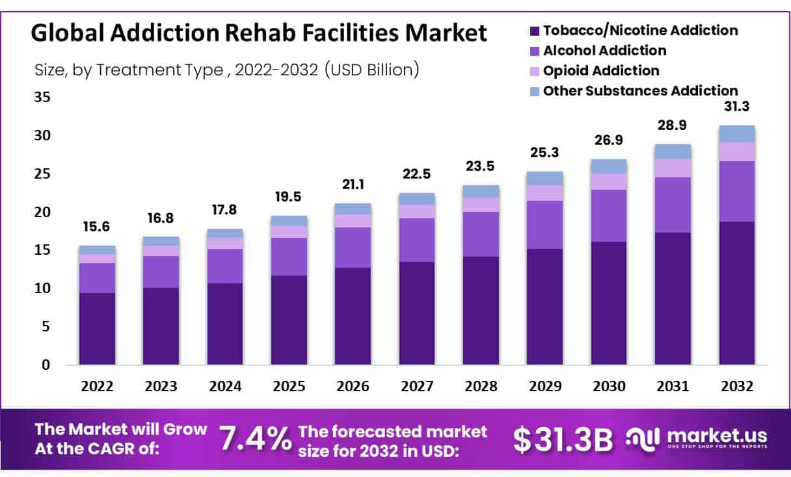

A look into the total market share of the Rehab Facilities market, including CAGR and a forecast into 2032. Shows a steady growth of about 1-2 billion US a year.

Deb, Trishita. “Addiction Rehab Facilities Market Size, Share: Cagr of 7.4%.” Market.Us Media, 26 Aug. 2025, media.market.us/addiction-rehab-facilities-market-news-2025/.

Figure 2- Nexus Recovery Center Financials
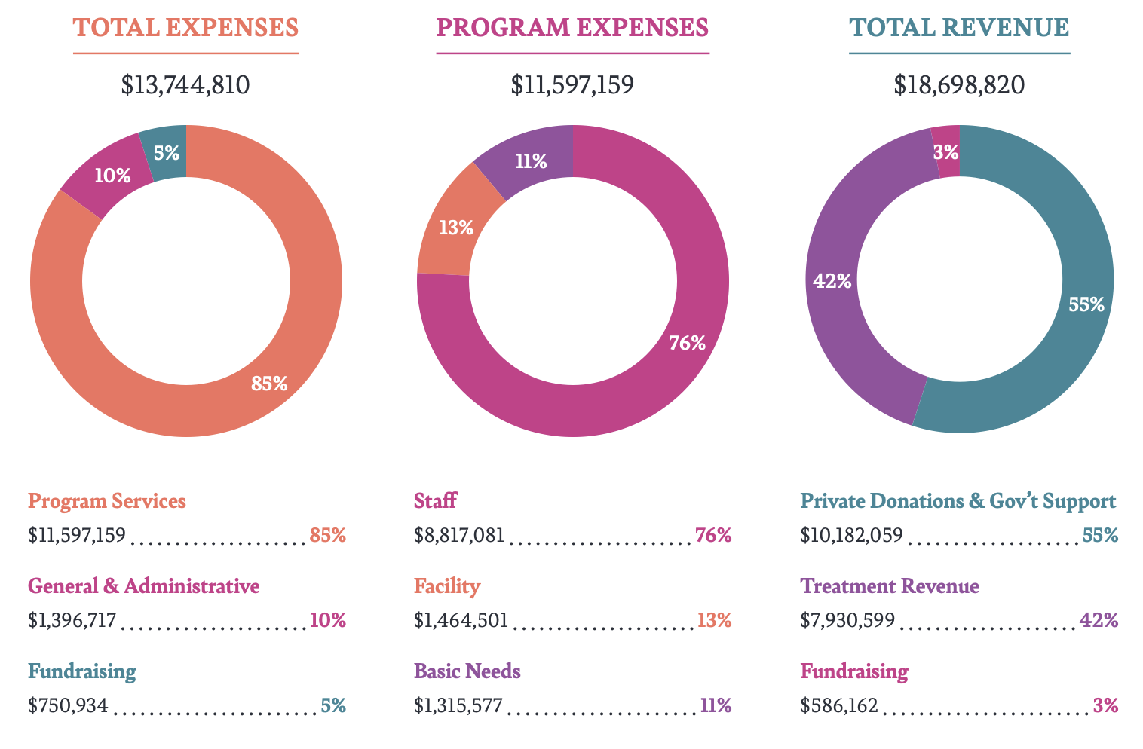
A graph showing Nexus Recovery Center’s revenue and expenses. Gives an accurate look into rehab facility management and costs incurred.

“Nexus Recovery Centers Annual Report.” Nexus Recovery, 2023, nexusrecovery.org/wp-content/uploads/2024/03/FY2023-Annual-Report-1.pdf.
Figure 3- Nexus Client Demographics
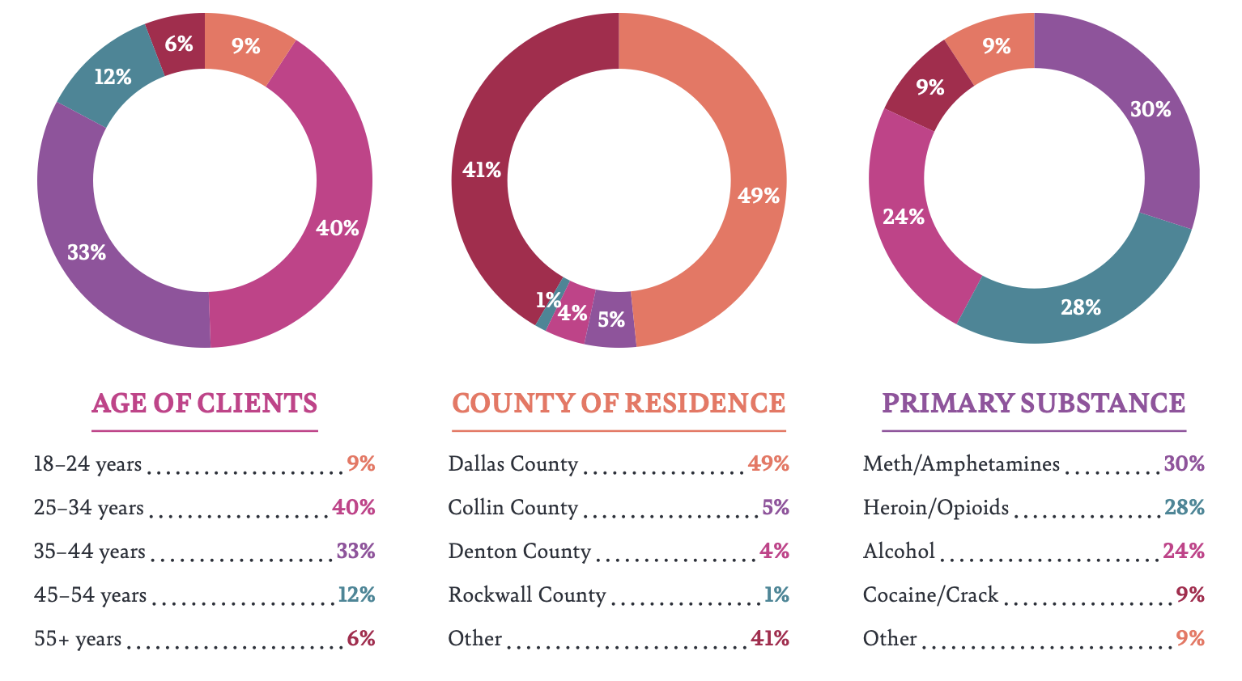
Client demographics of Nexus Recovery Centers, with age, county, and substance used. Provides a great breakdown of all relevant demographics, though be aware all of Nexus’s clients are women.

“Nexus Recovery Centers Annual Report.” Nexus Recovery, 2023, nexusrecovery.org/wp-content/uploads/2024/03/FY2023-Annual-Report-1.pdf.
Figure 4- CMS Market Share
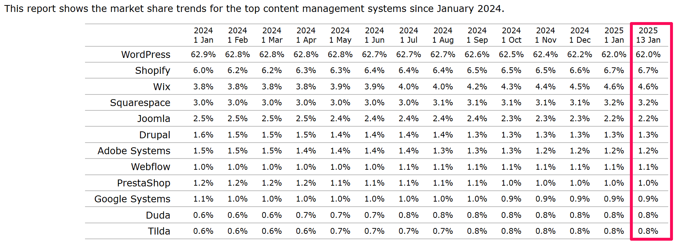
Graph showing market share of all website design tools, with WordPress being the clear market powerhouse.

“Wordpress Statistics: How Many People Use Wordpress in 2025?” SearchLogistics, 17 Mar. 2025, www.searchlogistics.com/learn/statistics/wordpress-statistics/.

Figure 5- Federal Drug Control Spending Percentages
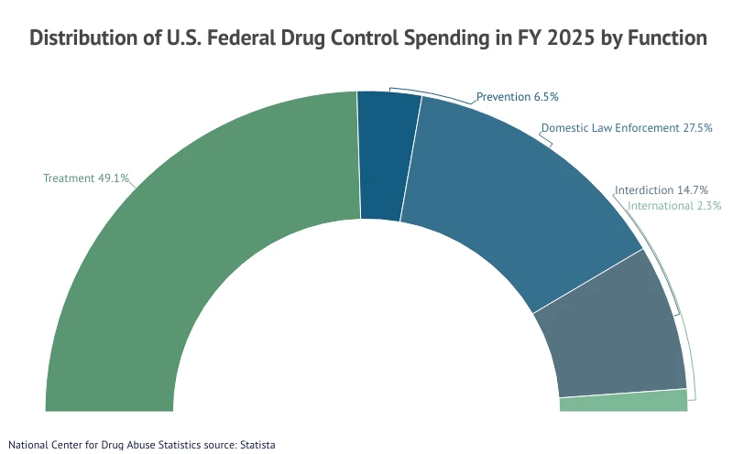
Federal Drug Spending in 2025, with treatment being the largest chunk of spending by the federal government.

“Substance Abuse and Addiction Statistics [2025].” NCDAS, 21 July 2025, drugabusestatistics.org/.

Figure 6- Socioeconomic status correlated with drug use over time
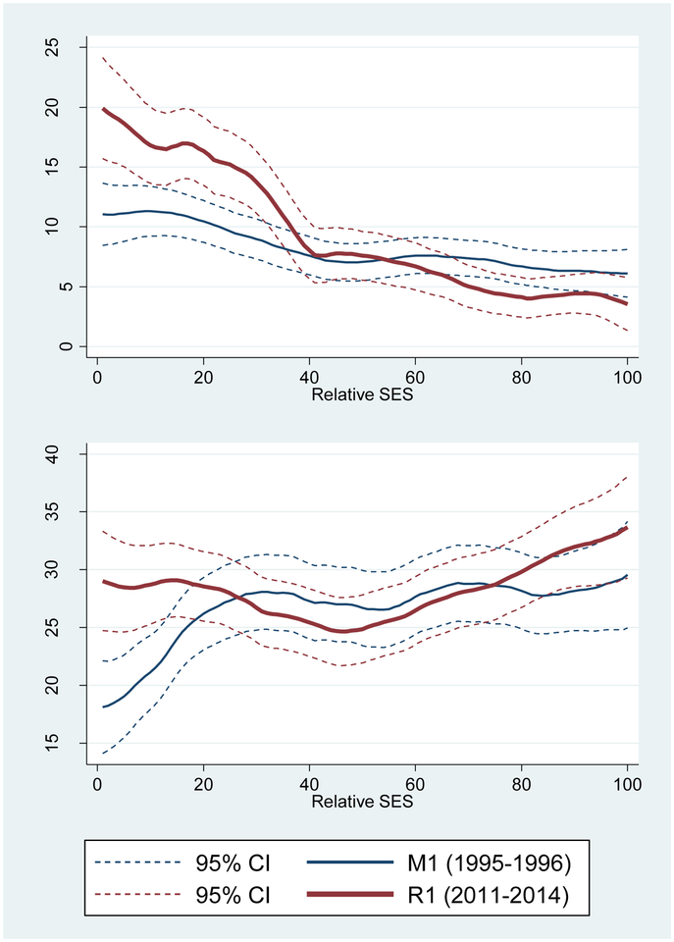
Socioeconomic factors are not correlated with drug use, rather the insecurity of one’s income due to potential economic downturns provide a larger role.

Glei, Dana A, and Maxine Weinstein. “Drug and Alcohol Abuse: The Role of Economic Insecurity.” American Journal of Health Behavior, U.S. National Library of Medicine, 1 July 2019, pmc.ncbi.nlm.nih.gov/articles/PMC6631323/.
Figure 7- Overall Market Trends based off of S&P total market return
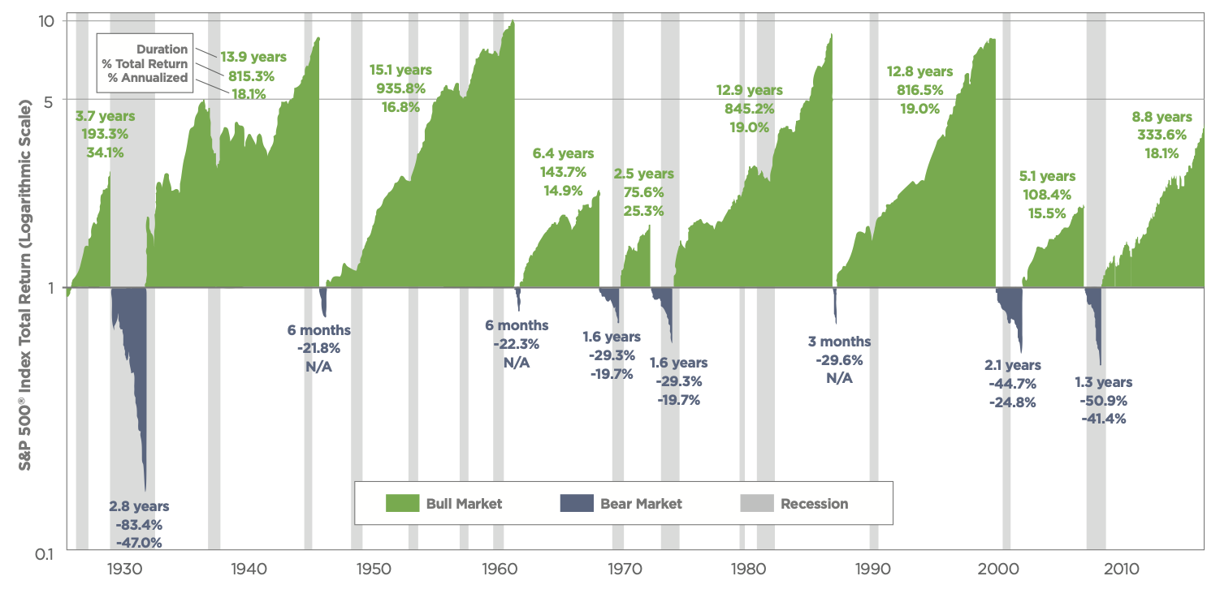
Market Trends showing bear and bull markets over the last 80 years.

“U.S. Bull and Bear Markets: Historical Patterns of the S&P 500® Index.” Guidestone, 30 June 2017, www.guidestone.org/-/media/retirement/pdf/bullvsbearmarketgraph.

Figure 8- number of facilities by ownership 2021-24
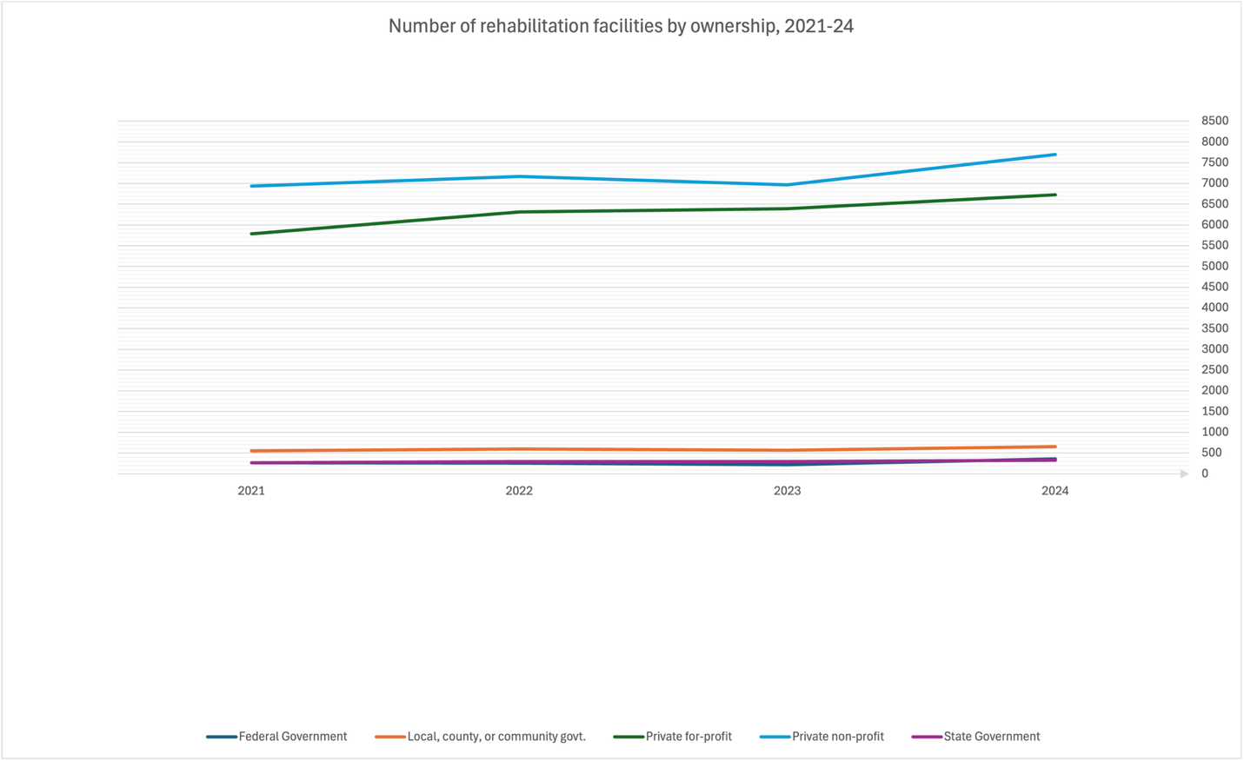
4 years of payment and total number of operating recovery facilities quantified by using a graph to show how many recovery centers opened and closed each year.

“2021 National Substance Use and Mental Health Services Survey (N-SUMHSS) Detailed Tables.” SAMHSA.Gov, SAMHSA, 21 Feb. 2023, www.samhsa.gov/data/report/2021-nsumhss-detailed-tables.
“2022 National Substance Use and Mental Health Services Survey (N-SUMHSS) Detailed Tables.” SAMHSA.Gov, SAMHSA, 25 Sept. 2023, www.samhsa.gov/data/report/2022-n-sumhss-detailed-tables.
“2023 National Substance Use and Mental Health Services Survey (N-SUMHSS) Detailed Tables.” SAMHSA.Gov, SAMHSA, 30 Oct. 2024, www.samhsa.gov/data/report/2023-n-sumhss-detailed-tables.
“2024 National Substance Use and Mental Health Services Survey (N-SUMHSS) Detailed Tables.” SAMHSA.Gov, SAMHSA, 30 Sept. 2025, www.samhsa.gov/data/report/2024-n-sumhss-detailed-tables.
Figure 9- Treatment at no charge for clients who cannot pay by recovery center type
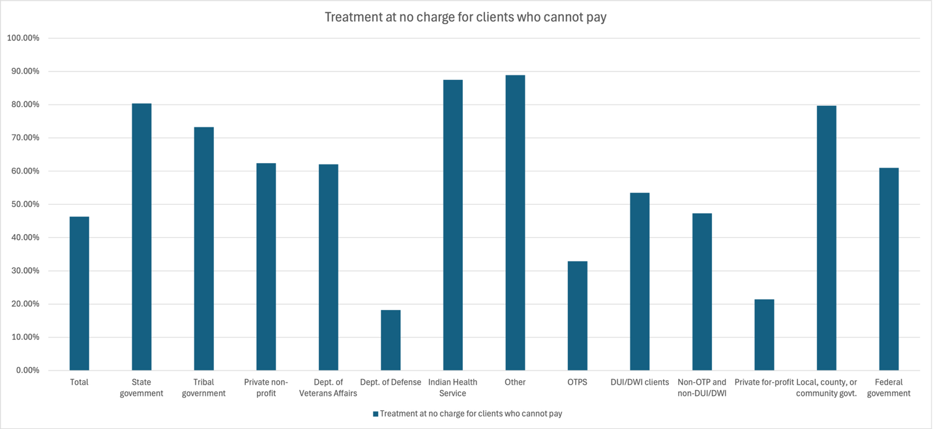
Same data as figure 8, using excel to show the percentage of how many recovery centers offer no charge treatments to customers who cannot pay, by using data from all different recovery center types.

“2021 National Substance Use and Mental Health Services Survey (N-SUMHSS) Detailed Tables.” SAMHSA.Gov, SAMHSA, 21 Feb. 2023, www.samhsa.gov/data/report/2021-nsumhss-detailed-tables.
“2022 National Substance Use and Mental Health Services Survey (N-SUMHSS) Detailed Tables.” SAMHSA.Gov, SAMHSA, 25 Sept. 2023, www.samhsa.gov/data/report/2022-n-sumhss-detailed-tables.
“2023 National Substance Use and Mental Health Services Survey (N-SUMHSS) Detailed Tables.” SAMHSA.Gov, SAMHSA, 30 Oct. 2024, www.samhsa.gov/data/report/2023-n-sumhss-detailed-tables.
“2024 National Substance Use and Mental Health Services Survey (N-SUMHSS) Detailed Tables.” SAMHSA.Gov, SAMHSA, 30 Sept. 2025, www.samhsa.gov/data/report/2024-n-sumhss-detailed-tables.
Figure 10- Payment Options for Most Populous Rehabilitation Options
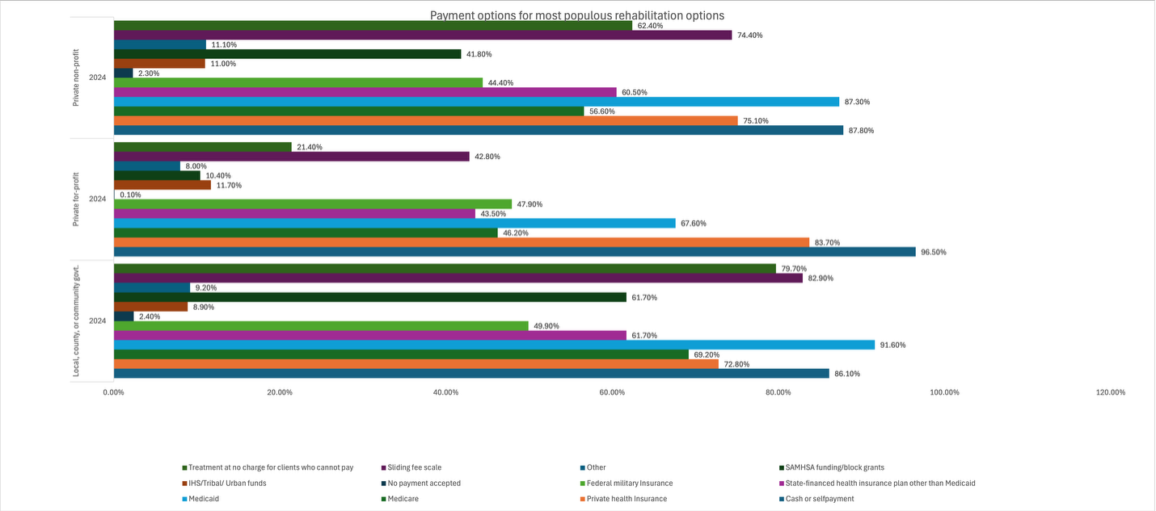
Same data as figures 8 and 9, this time showing the 3 largest types of recovery centers with what percentage of each payment type they accept.

“2021 National Substance Use and Mental Health Services Survey (N-SUMHSS) Detailed Tables.” SAMHSA.Gov, SAMHSA, 21 Feb. 2023, www.samhsa.gov/data/report/2021-nsumhss-detailed-tables.
“2022 National Substance Use and Mental Health Services Survey (N-SUMHSS) Detailed Tables.” SAMHSA.Gov, SAMHSA, 25 Sept. 2023, www.samhsa.gov/data/report/2022-n-sumhss-detailed-tables.
“2023 National Substance Use and Mental Health Services Survey (N-SUMHSS) Detailed Tables.” SAMHSA.Gov, SAMHSA, 30 Oct. 2024, www.samhsa.gov/data/report/2023-n-sumhss-detailed-tables.
“2024 National Substance Use and Mental Health Services Survey (N-SUMHSS) Detailed Tables.” SAMHSA.Gov, SAMHSA, 30 Sept. 2025, www.samhsa.gov/data/report/2024-n-sumhss-detailed-tables.
Figure 11- Images of one of the Fresh Start locations
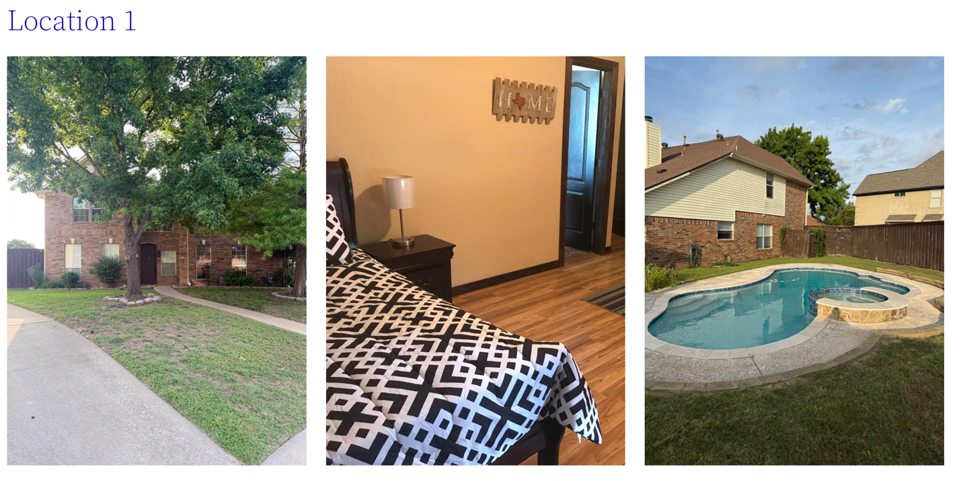
Showcases the living conditions in the average Fresh Start Christian Sober Living home, although this one does have a pool.

https://freshstartcsl.com/
Figure 12- Nexus’s Instagram homepage
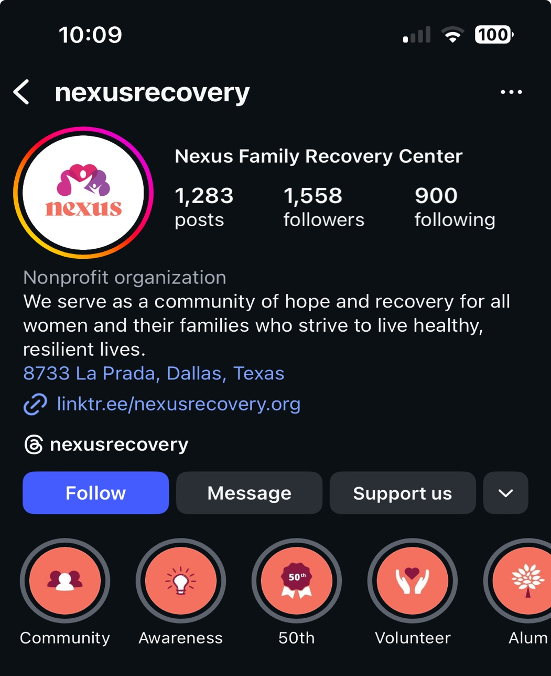
Nexus Recovery’s homepage, professional with many highlight reels to effectively showcase all they do.

https://www.instagram.com/nexusrecovery/

Figure 13- Cenikor X profile
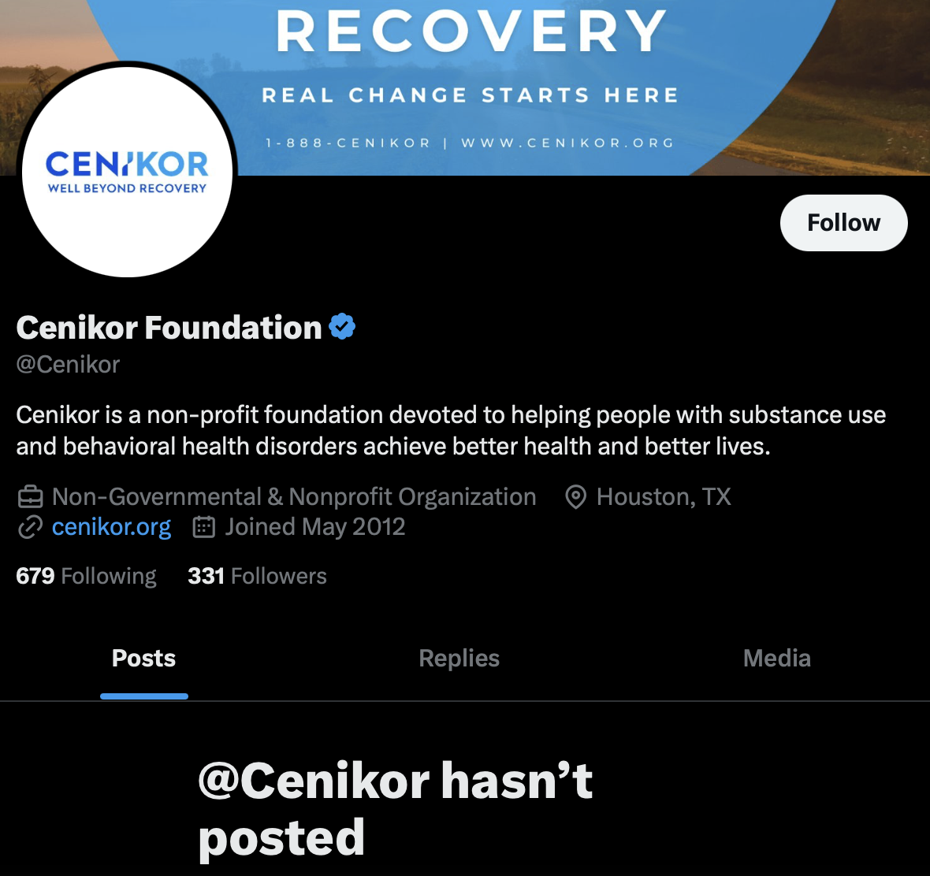
No posts, shows that Cenikor’s priority is not digital media, with the account being created in 2012.

https://x.com/Cenikor

Figure 14- Cenikor Locations
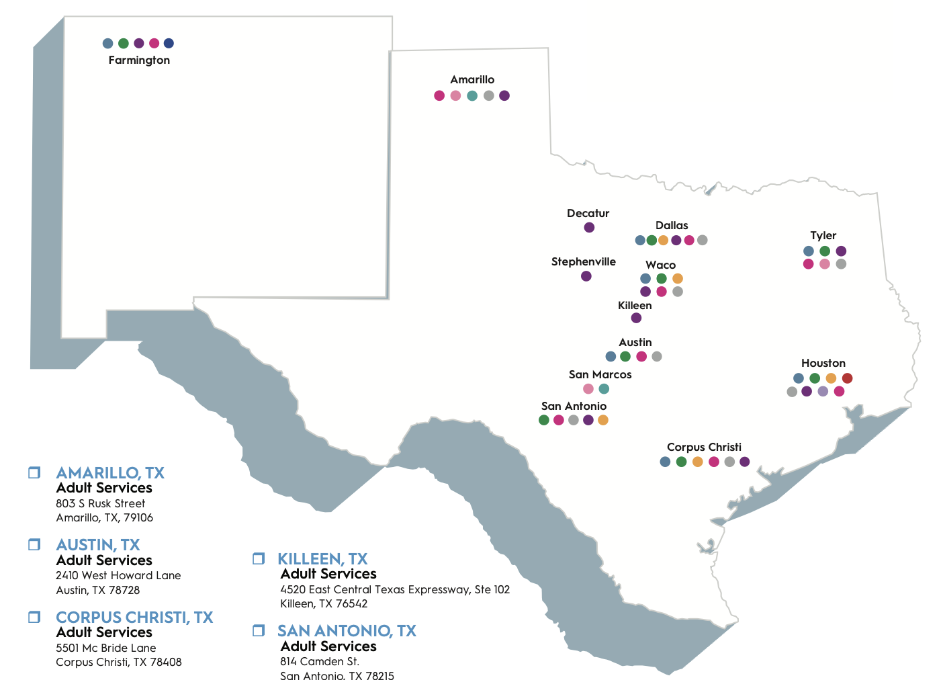
Cenikor’s locations nationally, with many located in the Dallas-Fort Worth area.

“2025 Annual Report.” Cenikor, 1 Oct. 2025, www.cenikor.org/annual-report/.

Figure 15- Engagement rate benchmarks
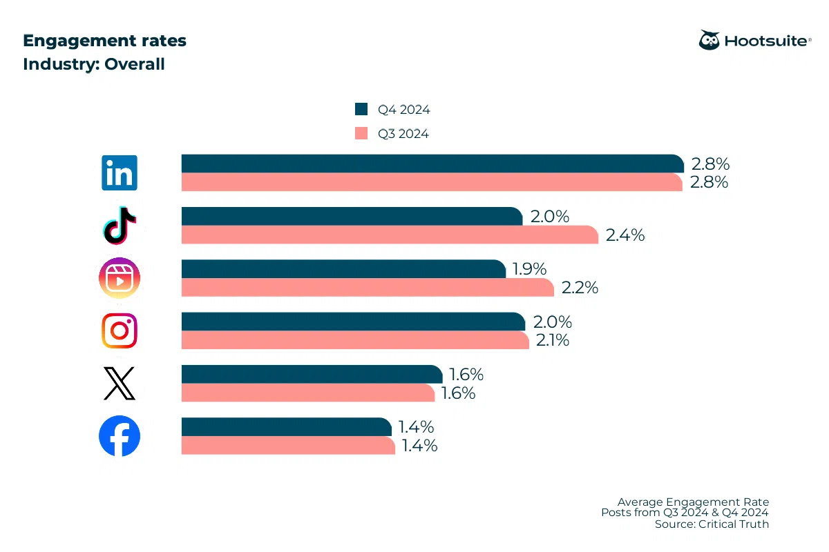
Engagement rate benchmarks, with both Q3 and Q4 of 2024 represented.

Newberry, Christina. “Engagement Rate Benchmarks and Formulas: 2025 Update.” Social Media Marketing & Management Dashboard, HootSuite, 13 Aug. 2025, blog.hootsuite.com/calculate-engagement-rate/.
Figure 16- Nexus Donor List
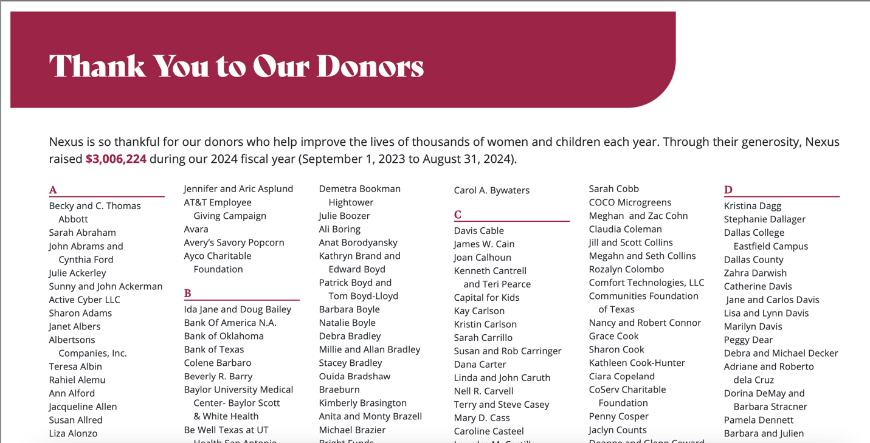
Fresh Start’s donor list will look similar to Nexus’s, however with tiers based on how much was donated by the individual or organization.

“Nexus Recovery Centers Annual Report.” Nexus Recovery, 2023, nexusrecovery.org/wp-content/uploads/2024/03/FY2023-Annual-Report-1.pdf.

